QWERTY Quirk

Safou

**Problem Statement:**

A common mistake happens when you accidentally shift your hands one key to the right on the keyboard. For example, 'Q' becomes 'W', 'J' becomes 'K', and so on. Your task is to fix this mistake and decode the message that was typed this way.

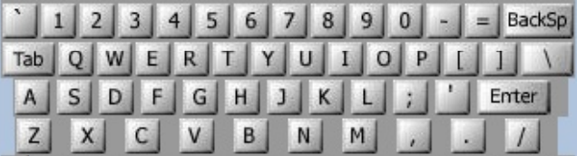

**Input:** You are given T test cases where:

Input consists of several lines of text. Each line may contain digits, spaces, upper case letters (except Q, A, Z), or punctuation shown above [except back-quote (‘)]. Keys labelled with words [Tab, BackSp, Control, etc.] are not represented in the input.

**Output:**

You are to replace each letter or punctuation symbol by the one immediately to its left on the ‘QWERTY’ keyboard shown above. Spaces in the input should be echoed in the output.

**Example 1:**

Input:

O S, GOMR YPFSU/

Output:

I AM FINE TODAY.

**Example 2:**

Input:

YS;L OD VJRS[. DJPE ,R UPIT VPFR/

Output:

TALK IS CHEAP, SHOW ME YOUR CODE.

**Flag:**

To generate the flag, sum the ASCII values of all characters decoded from all test cases. The final flag should be formatted as:

**Flag{ascii_sum}**